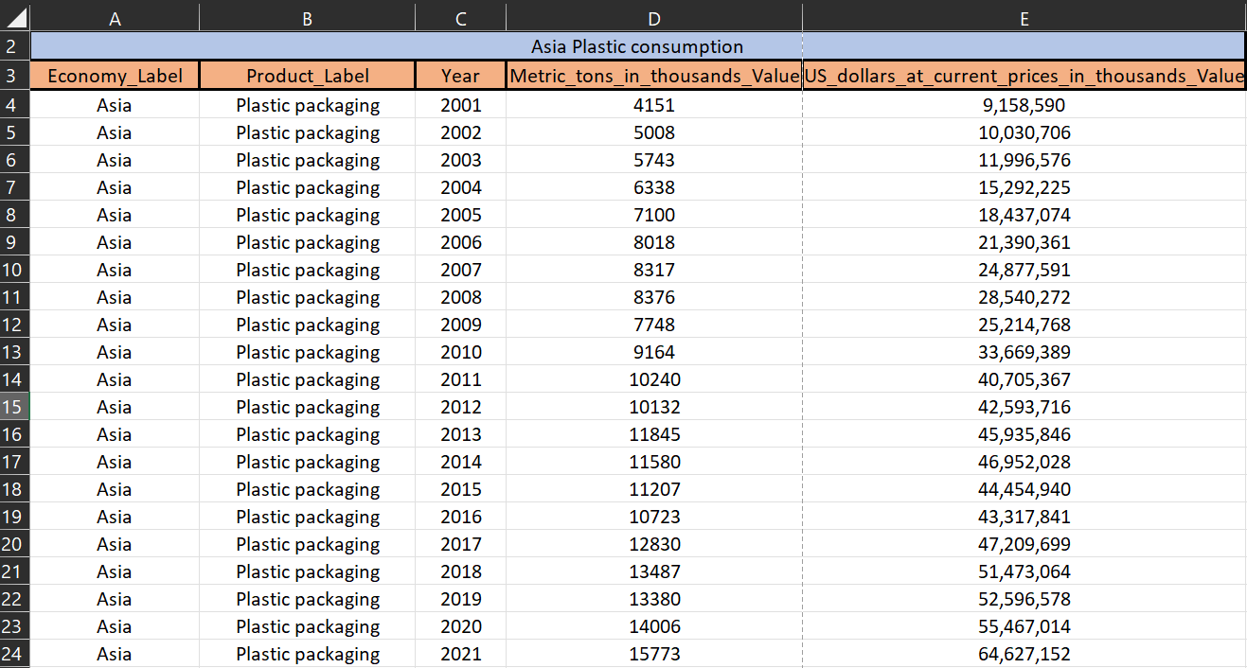

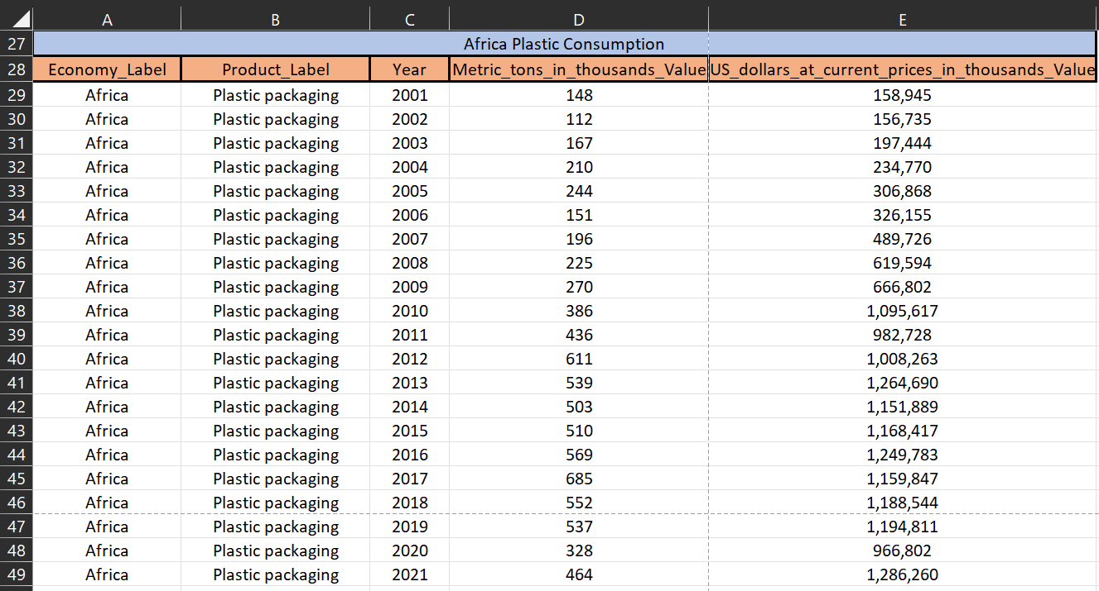

2) Central Tendency:

1. Arithmetic mean:
2. Simple Arithmetic mean:

It is equal to the sum of all the values in the group of data divided by the total number of values.

For Asia: summation of total revenue / 20 :

= 36697039.85

For Africa: summation of total revenue / 20:

= 843734.5

1. Complex arithmetic mean:

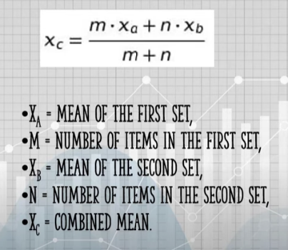

= xa: 36697039.85

= m & n: 20

= xb: 843734.5

20*36697039.85 + 20*843734.5

= ----------------------------------------------- = 18770387.175

20+20

1. Median

1. Asia plastic distribution revenue median from 2001 to 2021: 

= 40705367

B) Africa plastic distribution revenue median from 2001 to 2021: 

= 982728

1. Mode:
2. Asia plastic distribution revenue mode for 2001 to 2021: 

= no mode available as such no repetitive value

1. Africa plastic distribution revenue mode for 2001 to 2021: 

= no mode available as such no repetitive value

3) Measures of Dispersion:

1. Range :

find max value in dataset = max

find min value in dataset = min

range = max – min

Asia:

max = 64627152

min = 9158590

range = 64627152 – 9158590 = 55468562

Africa:

Max = 1286260

Min = 156735

Range = 1286260 – 156735 = 1129525

1. Quartile Deviation:

Quartile deviation is a statistic that measures the deviation in the middle of the data. Quartile deviation is also referred to as the semi interquartile range and is half of the difference between the third quartile and the first quartile value. The formula for quartile deviation of the data is

Q.D = (Q3 - Q1)/2

Asia:

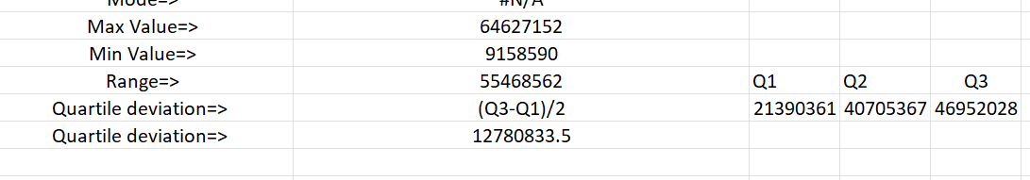

Q1 =QUARTILE.INC($E$3:$E$23,1)

Q2 =QUARTILE.INC(E3:E23,2)

Q3 =QUARTILE.INC($E$3:$E$23,3)

Africa:

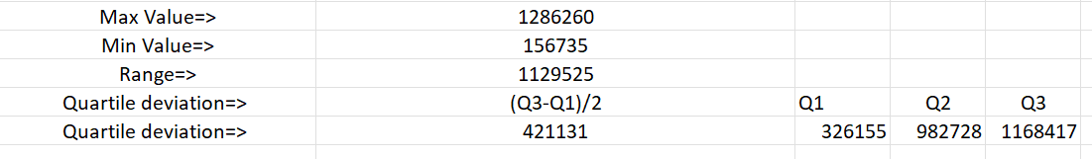

Q1 =QUARTILE.INC($E$39:$E$59,1)

Q2 =QUARTILE.INC($E$39:$E$59,2)

Q3 =QUARTILE.INC($E$39:$E$59,3)

1. **Mean Absolute Deviation:**

The mean absolute deviation of a dataset is the average distance between each data point and the mean. It gives us an idea about the variability in a dataset.

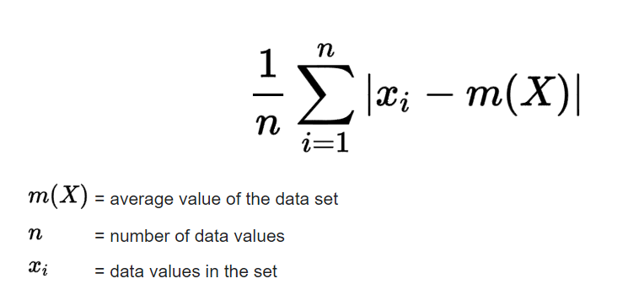

Asia:

Mean Absolute Deviation=

Find avg by using avg formula in excel then

Find abs value for each data point = ABS(avg-datapoint)

Take avg of abs value of data points. And this avg will be mean absolute deviation



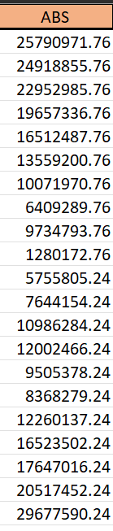

Africa:

Mean Absolute Deviation=

Find avg by using avg formula in excel then

Find abs value for each data point = ABS(avg-datapoint)

Take avg of abs value of data points. And this avg will be mean absolute deviation



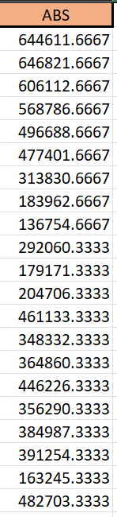

1. Standard Deviation:

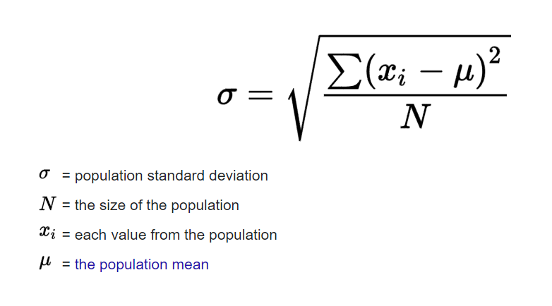

For Asia standard deviation is: =STDEV.S(E3:E23) -> 16504539.8

For Africa standard deviation is: =STDEV.S(E39:E59) -> 428010.2384

1. Standard deviation a superior measure of dispersion compared to alternative methods

YES the standard deviation a better measure the dispersion of data than the range. We know that the range and the standard deviation both are a measure of dispersion. The range takes only extreme values that are maximum and minimum values. It does not cover all observation in the data set.

Standard deviation is considered to be the best measure of dispersion and is therefore, the most widely deviation affects used measure of dispersion. values and thus provides information about the complete series. Because of this the value of the standard deviation.

1. It is based on all reason, a change in even one value

(iii) It is useful in advanced statistical calculation like the comparison

(ii) It is independent of origin but not of scale.

(iv) It can be used in testing of hypothesis.

(v) It is capable of further algebraic treatment.

1. Interpretation of data using descriptive statistics

Descriptive statistics involves summarizing and organizing the data so they can be easily understood. Descriptive statistics, unlike inferential statistics, seeks to describe the data, but does not attempt to make inferences from the sample to the whole population. Here, we typically describe the data in a sample.

Types of Descriptive Statistics?

Descriptive statistics are broken down into two categories. Measures of central tendency and measures of variability (spread).

The measure of Central Tendency

Central tendency refers to the idea that there is one number that best summarizes the entire set of measurements, a number that is in some way “central” to the set.

Mean / Average

Mean or Average is a central tendency of the data i.e. a number around which a whole data is spread out. In a way, it is a single number that can estimate the value of the whole data set.

Let’s calculate the mean of the data set having 8 integers.

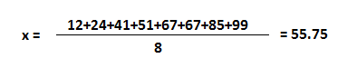

Image 2

Median

Median is the value that divides the data into 2 equal parts i.e. number of terms on the right side of it is the same as a number of terms on the left side of it when data is arranged in either ascending or descending order.

Note: If you sort data in descending order, it won’t affect the median but IQR will be negative. We will talk about IQR later in this blog.

Median will be a middle term if the number of terms is odd

Median will be the average of the middle 2 terms if a number of terms is even.



Image 3

The median is 59 which will divide a set of numbers into equal two parts. Since there are even numbers in the set, the answer is the average of middle numbers 51 and 67.

Note: When values are in arithmetic progression (difference between the consecutive terms is constant. Here it is 2.), the median is always equal to the mean.



Image 4

The mean of these 5 numbers is 6 and so median.

Mode

Mode is the term appearing maximum time in data set i.e. term that has the highest frequency.



Image 5

In this data set, the mode is 67 because it has more than the rest of the values, i.e. twice.

But there could be a data set where there is no mode at all as all values appear same number of times. If two values appeared same time and more than the rest of the values then the data set is bimodal. If three values appeared same time and more than the rest of the values then the data set is trimodal and for n modes, that data set is multimodal.